# **ANVY INC**

**Street :** No. 103, 3016-10 Avenue N.E.  
 Calgary Alberta, Canada T2A6A3  
**Phone :** 403.291.2244  
**Fax :** 403.291.2246  
**E-mail :** [long@anvyinc.com](mailto:long@anvyinc.com)

# 

USER Manual

Contents

**ANVY INC** 0

0

About The Worktraq 1

**What is Worktraq.** 1

Front-end 2

**Login the worktraq system.** 2

Financial Summary 3

**Home** 3

**Catalogue** 3

**Order** 4

**Shipping** 4

**Support** 5

**Logout the woktraq system** 5

**Setting user** 5

Category 7

**Functional** 7

**Show all product** 7

**Seach Product by Tag, Quick Search** 7

**View details product.** 8

Order 9

**Order History** 9

**Search Order** 9

**Create Order and Add Product to Order.** 10

**Edit Product in Order** 19

**Delete Product in Order** 20

**Edit Order** 21

**View Order** 22

**Delete Order** 22

Shipping 24

**View Shipping History** 24

Support 25

**Feedback** 25

# About The Worktraq

## **What is Worktraq.**

Anvy Inc′s Worktraq OPM System enables you to create order and manage your promotional, marketing and POP purchases from the comfort of your office and save them for re order at a later date. Whether you are rebranding your current locations or opening new and exciting stores, our worktraq system allows your managers the freedom to order products and printed materials direct from our shop. We create a simple database of products and prices, your managers and affiliates login into the system with proprietary usernames and select from a pre-selected list of items, the items are printed and shipped to the mangers location within five business days. As a superuser, you have the ability to lock certain items from the ordering list or to allow managers and affiliates to order any item they need for their location. We have the option to customize the database for the individual users and you will have the option to approve and review all orders before submitting to us.

# Front-end

## **Login the worktraq system.**

**Step 1 :** Go to the address website : <http://worktraq.anvy.net>. The page login website :

Here you can login account :

* Admin – Full function
* User – depends on providing admin (default view order for this user order)

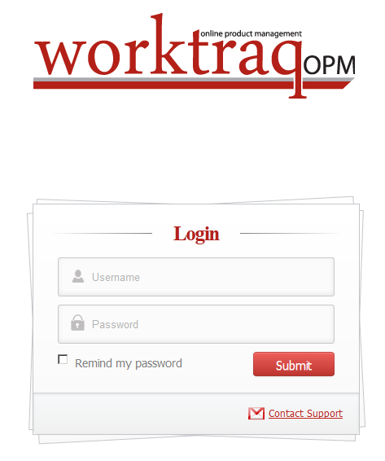  
**Step 2:** Please enter the your username or password to login the worktraq system. If the your username or password is not correct, the system will appear alert. If you forget your account, please contact … . We sent your account via email, phone…

# Financial Summary

## **Home**

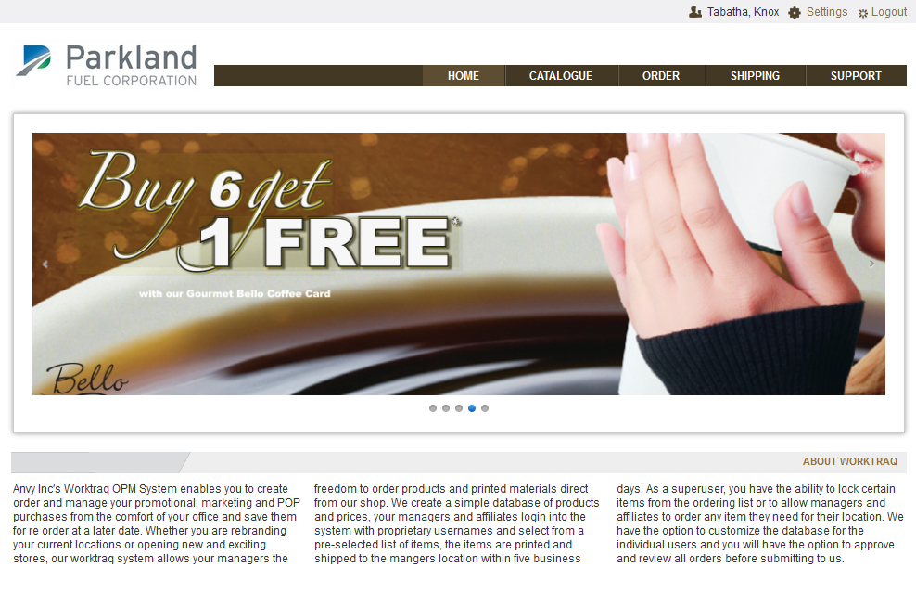

## **Catalogue**

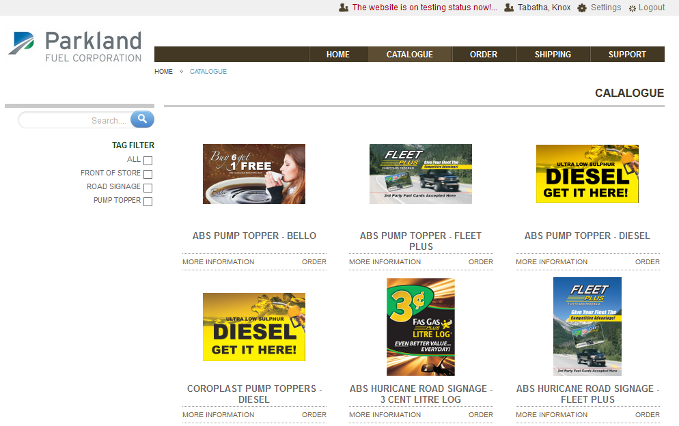

## **Order**

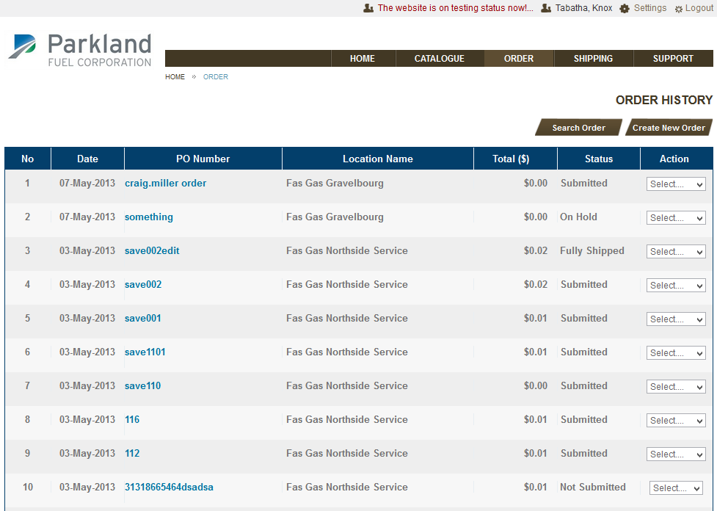

## **Shipping**

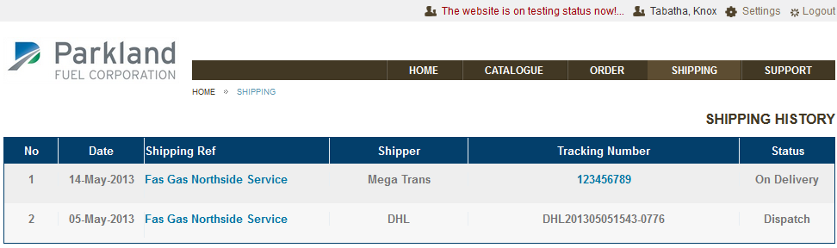

## **Support**

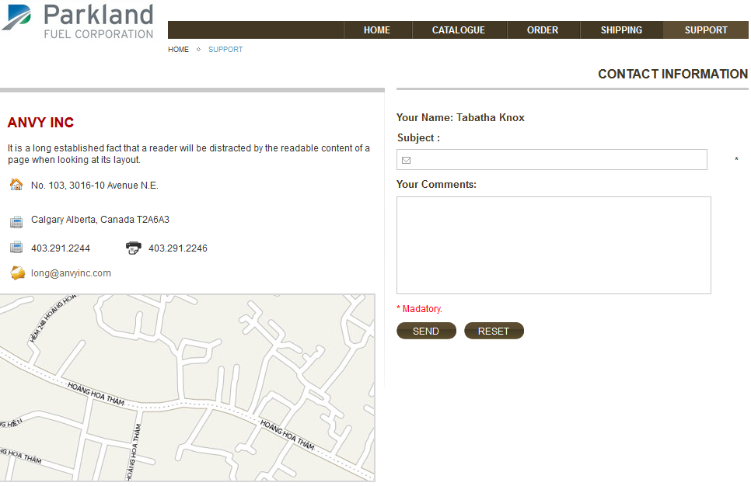

## **Logout the woktraq system**

**Step 1:** Please click the link Logout at the top-right.

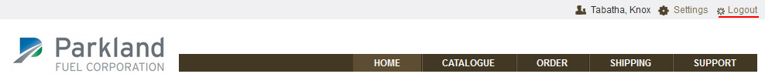

## **Setting user**

**Step 1:** Please click settings link at the top right near Logout.

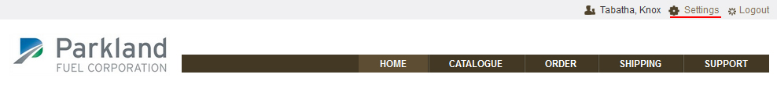

**Step 2:** User can change password, view details information user…

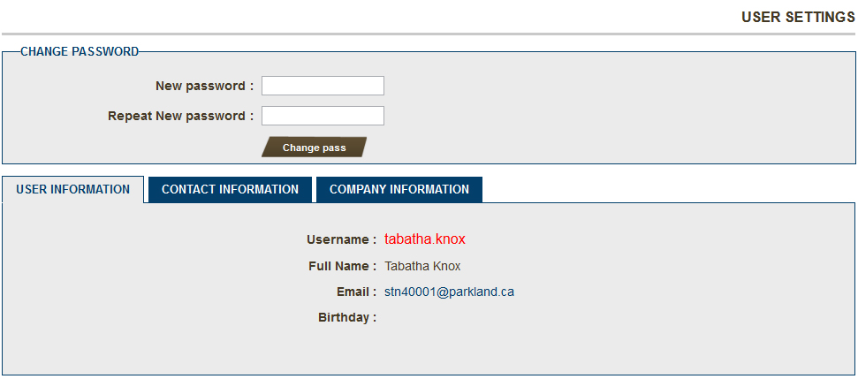

# Category

## **Functional**

* Show all product
* Allow search products by tag, name, quick search.
* View details product.

## **Show all product**

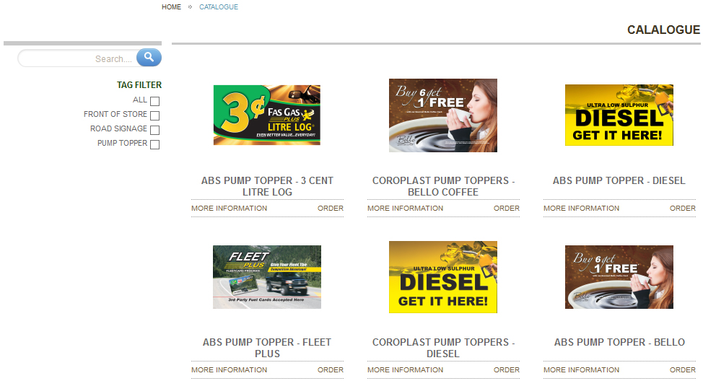

## **Seach Product by Tag, Quick Search**

**Step1:**  Check on tag fillter to search product. The sysytem will search by tag what you checked.

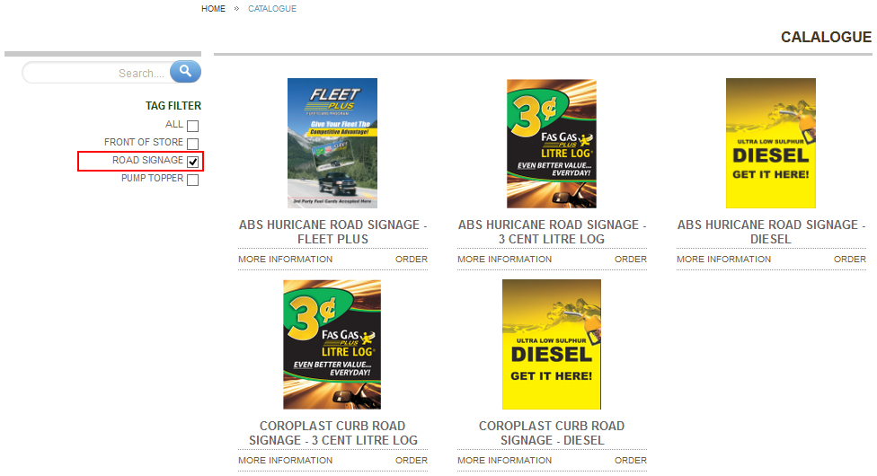

Allow search by tag and quick search together.

**Step 1:** Check tag in tag fillter

**Step 2:** Enter the quick search

**Step 3:** Click button Search shortcut.

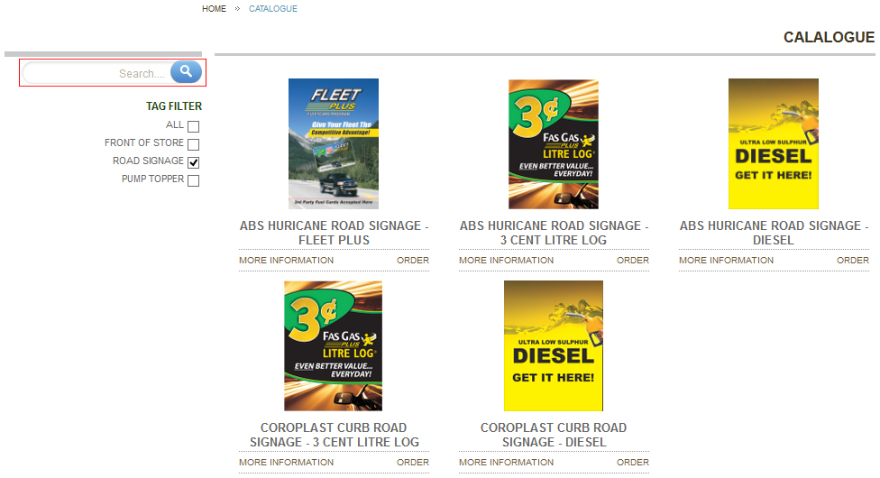

## **View details product.**

In Page “CATALOGUE PRODUCTS ”Click link bottom “MORE INFORMATION” of product or   
click thumbnail image product.

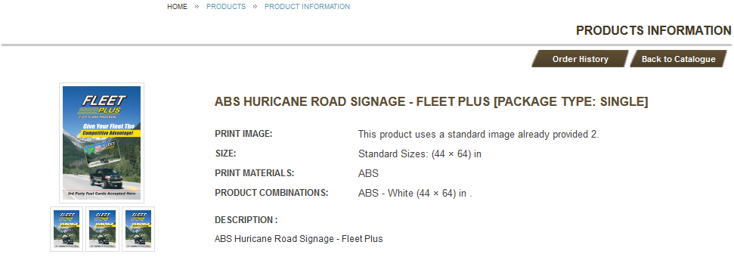

# Order

## **Order History**

**Step 1:** Click menu “ Order “ on website. The Order History will appear.

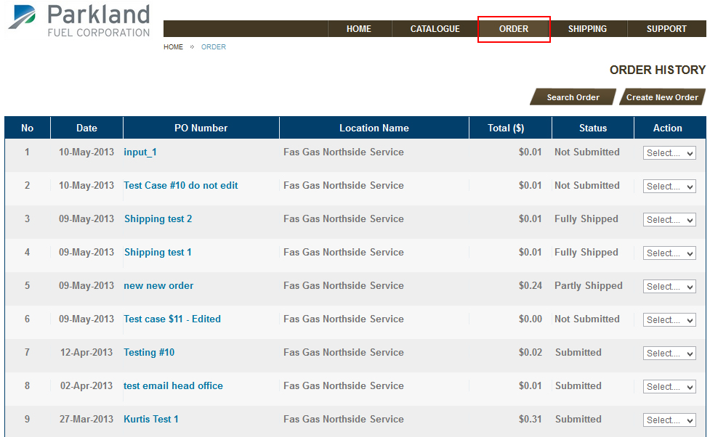

## **Search Order**

**Step 1:** Click Search Order. You can search by

* PO Number
* From Location
* Status of order
* Created by
* Create date
* Date time ( from … to..)

**Step 2:** Click Search.

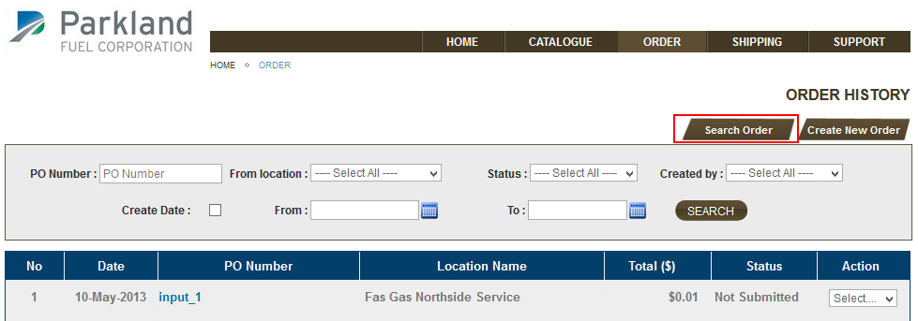

## **Create Order and Add Product to Order.**

**Step 1:** Click”Create Order” button. The system will appear or popup depending on templates.   
Click OK to new order.

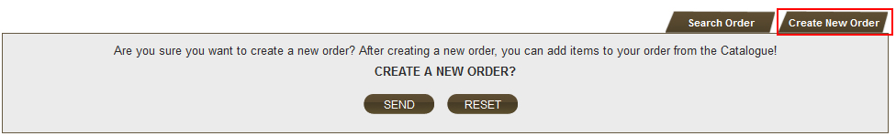

**Step 2:** Add product to Order   
(For Admin or Customer user allowed create new order – default Customer user have not create new order)

The catalogue will appear, User can view, and select product by click “More Information” or click Thumbnail Image.

* Customer User (default only view products in catalogue – products information)
  + Please click MORE INFORMATION links or click products image of products to view 🡪 view products information.
  + Customer user (default – not allowed create order) you do not have permission create order,  
    you can only see products information for this product.
  + Customer user (allowed create order by Administrator) you can create order when you click link ORDER, as administrator

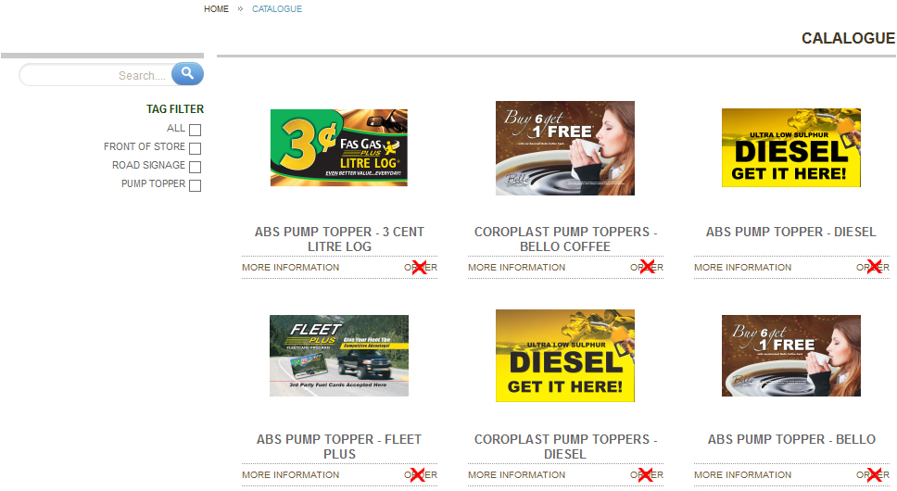

* Admin (Full permission)
  + If you login account Administrator, you can create order, edit order, delete order…..   
    When you click links ORDER you can see permission allowed

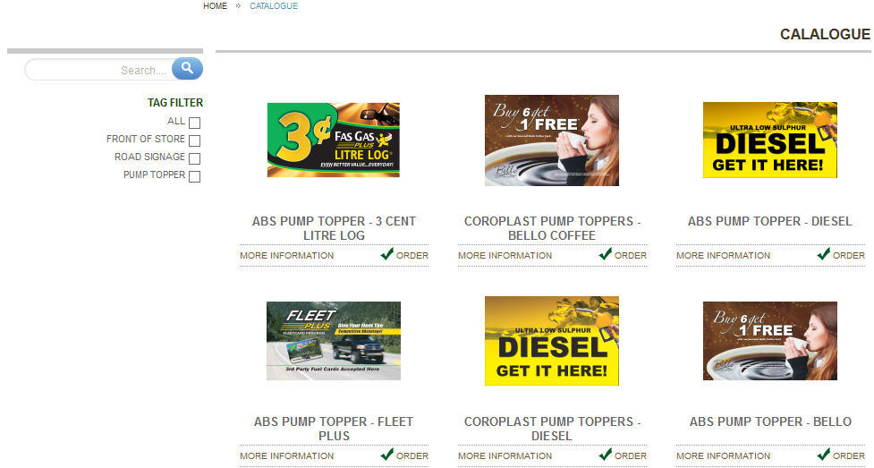

**Step 3:** In the product information, you can view more information about the product. If you want add product to Order. Click button “ADD TO YOUR ORDER”.

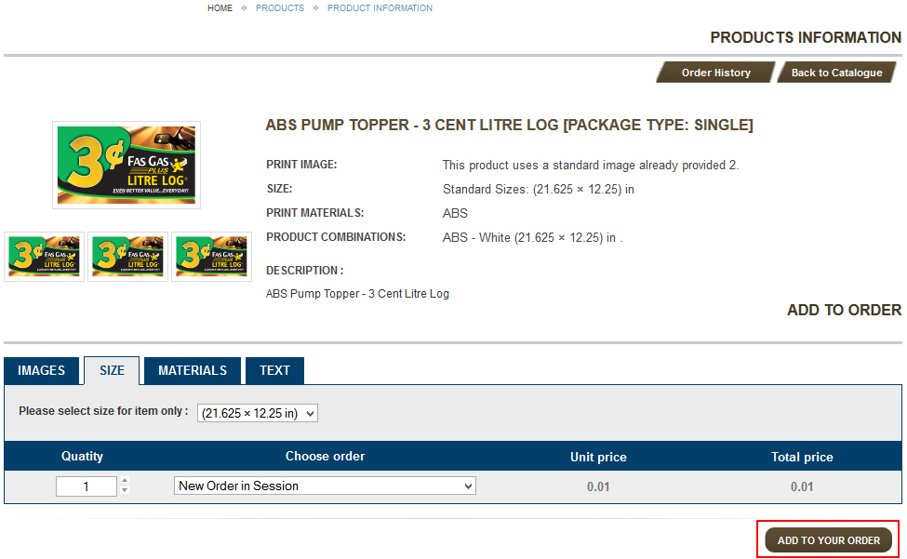

**Step 4:** After click button “ADD TO YOUR ORDER”. The Order form apper. You can see 4 tabs for properties of product. Click each Tab in Order Form.

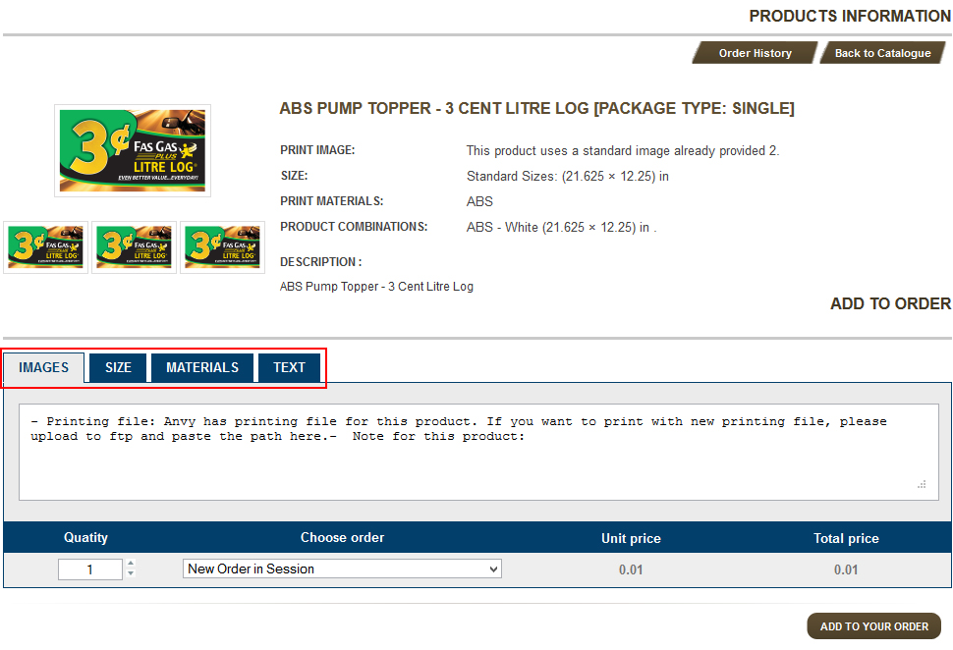

Enter the note for product.

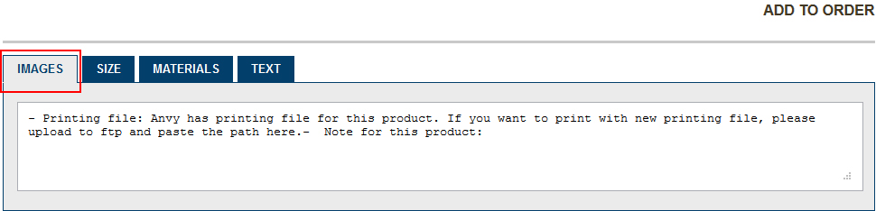

Select size. Some products many size, user can select size have for product.

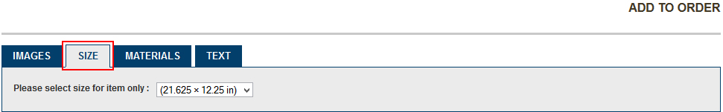

Select Material, include Material, Thichness, Color.

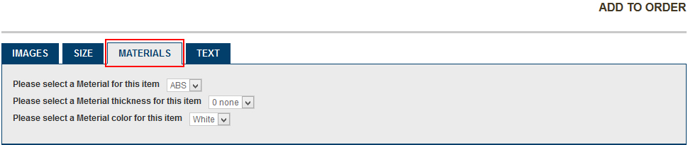

Select text

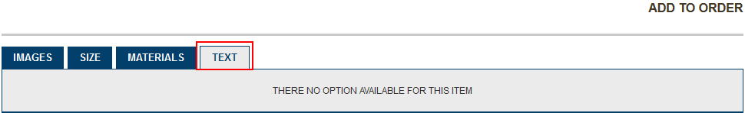

**Step 5:** Enter quantily for product:



**Step 6:**

* 1 - Choose Order in system
* 2 - Click to “ ADD TO YOUR ORDER “ button when choose order finish.

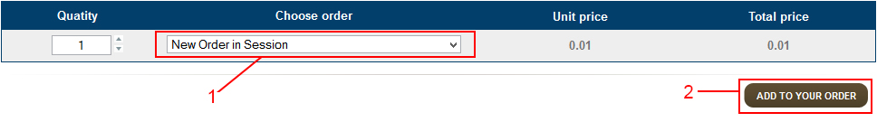

Step 7: After click to “ ADD TO YOUR ORDER “ button. The Order Details will apper. Information Tab.

* 1 – Input information the PO Number – required filed
* 2 - Input information Order Ref – required filed
* Input information to other filed in form information (Notes, Date reuired)

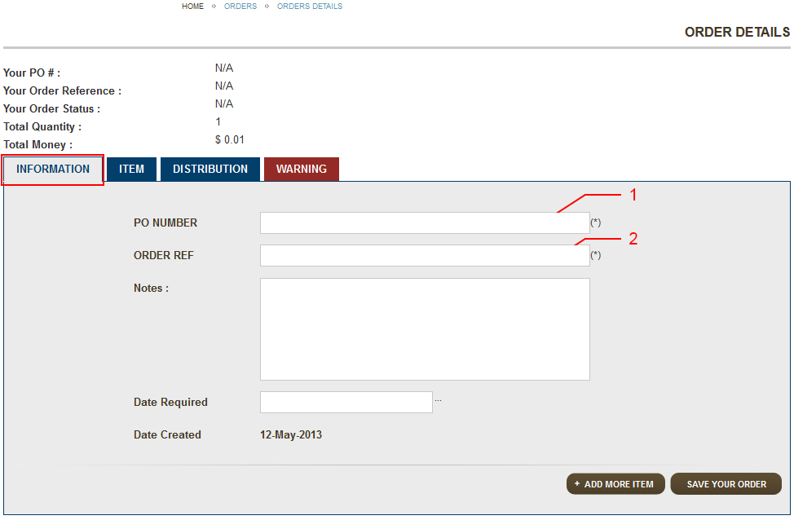

In Tab Item : All products what you add to order.

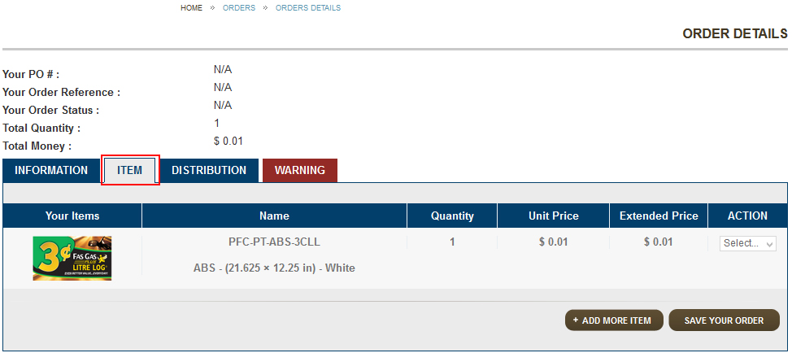

In Tab Distribution: ( *view Allocation for Location details*)  
Default you can see collapse all

* 1 or 3 You can click if you want show allocation for location details (Expand all)
* 2 You do not show allocation for location details (Collapse all - default)

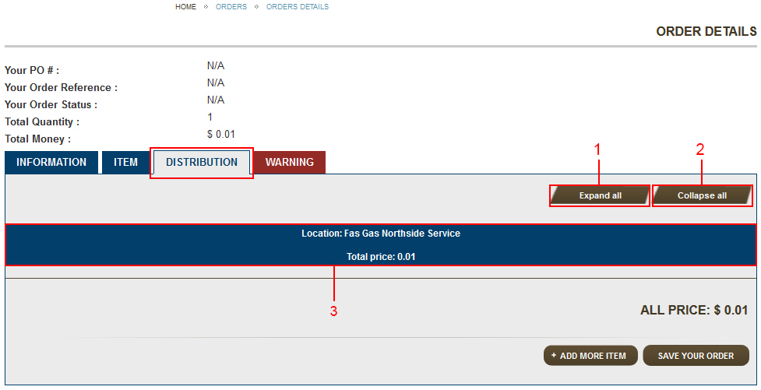

When you click Expand all (1 or 3)

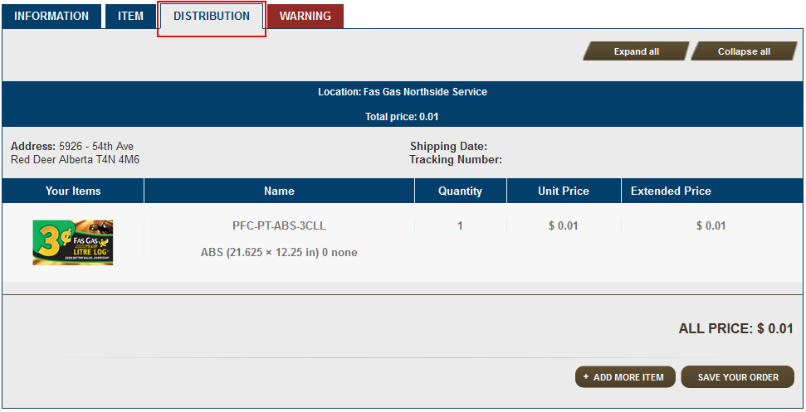

**Step 8:** When you input full information (Order – Step 7)

Please click button “SAVE YOUR ORDER” – 1, products you choice will save.

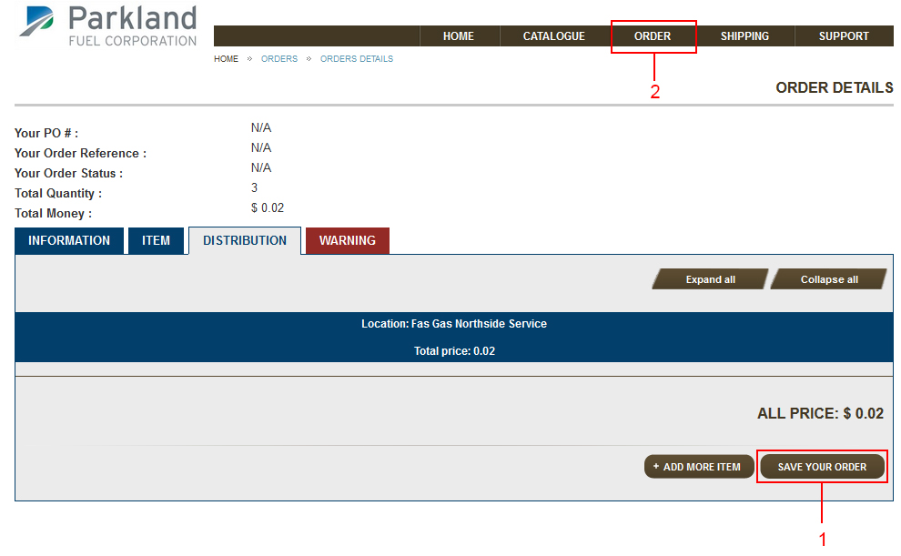

Click “ORDER” In menu top - 2. You can see this all products save please click

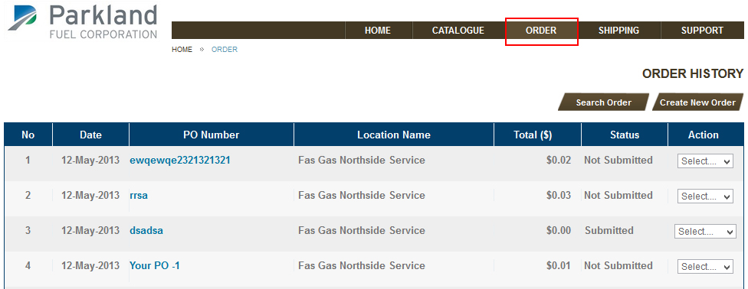

**Step 9:**

* 1 Status : Not Submited for order your save
* 2 You will select Edit this product

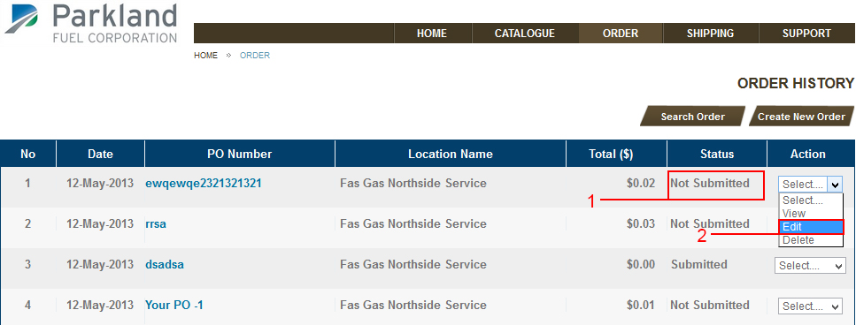

**Step 10:**

* 1 Information – ( Order - Step 7) - required
* 2 Click button “SUBMIT YOUR ORDER” when Information exactly

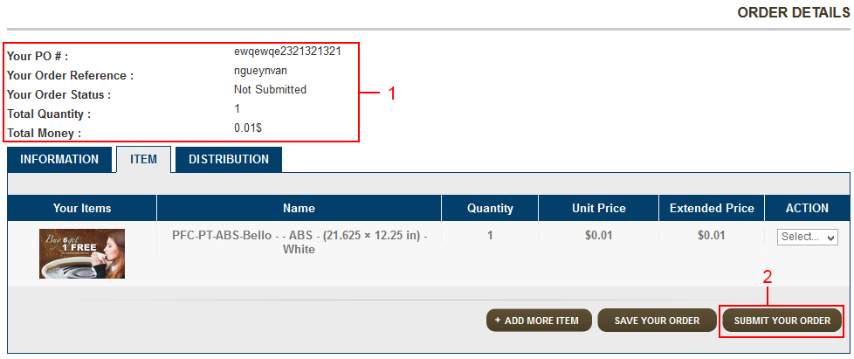

**Step 11:**

You see status this products you choice : Submitted

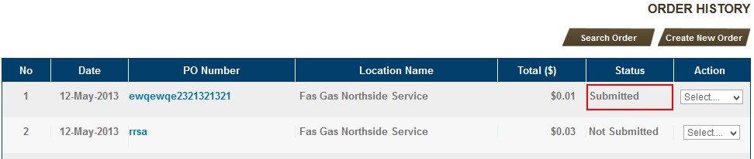

Note :

* SUBMIT YOUR ORDER : The order is change status “ Submitted” or “ Approval ”
* SAVE YOUR ORDER : Order is not submit, it save in database, user can’t edit, delete
* ADD MORE ITEM : Add more item to this order.

**Allocation for location**

**Step 1:** In the Items tab of Details Order’s Page. Click drop-down to allocate products. Select Allocate

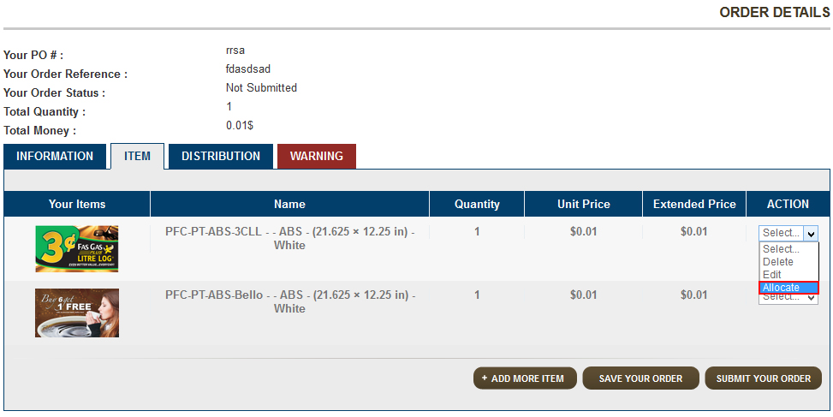

**Step 2 :** The page to allocation location

How:

* 1 - Button Add location
* 2 – Change Quantity
* 3 – Delete location selected
* 4 – Total quantity selected this product
* 5 – Total quantity allocate must also choose – when the Remaining to allocate is 0. User can save (6)
* 6 – Save allocate
* 7 – Cancel allocate

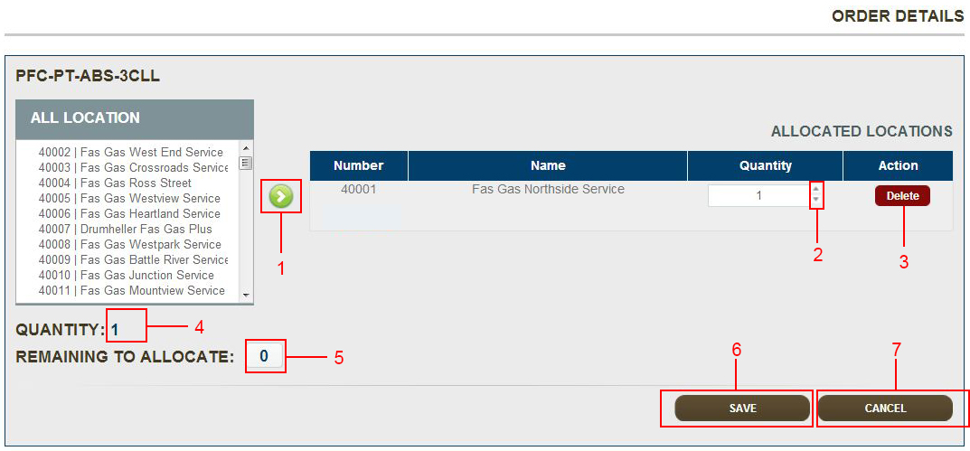

## **Edit Product in Order**

**Step 1:** In the Items tab of Details Order’s Page. Click drop-down to allocate products. Select Edit.

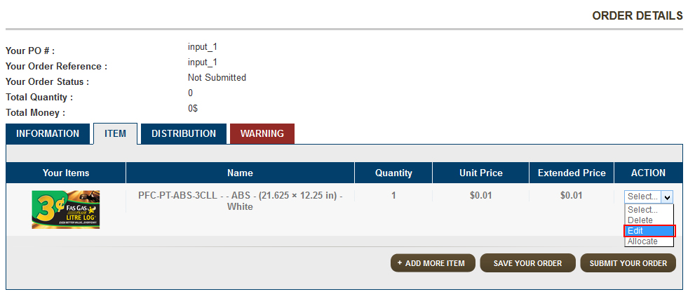

**Step 2:** Now, user can chang quantity, size, material, text of products. And Click “Save to Order”

Similar **Create Order and Add Product to Order – Step 4**



## **Delete Product in Order**

**Step 1:** In the Items tab of Details Order’s Page. Click drop-down to allocate products. Select Delete.

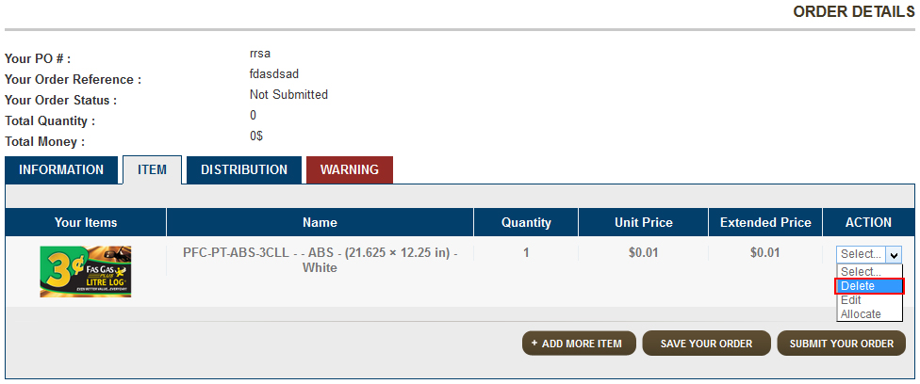

**Step 2:** The Conform form will appear. Click OK if you want to delete this product..

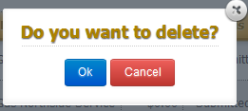

## **Edit Order**

**Step 1:** Click drop-down in order and select edit.

Note : User can edit orders what is **not-submitted**, **pending**, **on session** .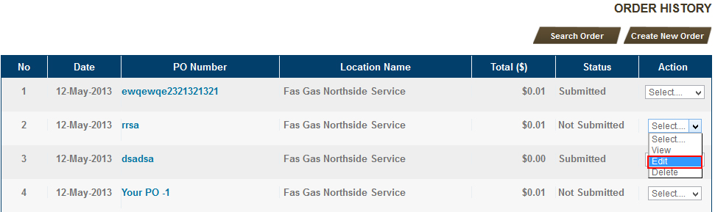

**Step2 :** In tab “INFORMATION” edit PO Number, Order Ref, chooise Material, Quantity of Products, Allocate to Locatioan and Click Submit or Save Order

Similar **ORDER – STEP 7**

* 1 – Enter the PO Number – required filed
* 2 - Order Ref – required filed



## **View Order**

**Step 1:** Click drop-down in Menu Order and select view.

Note:

* All order can view
* User must roles to view order another.

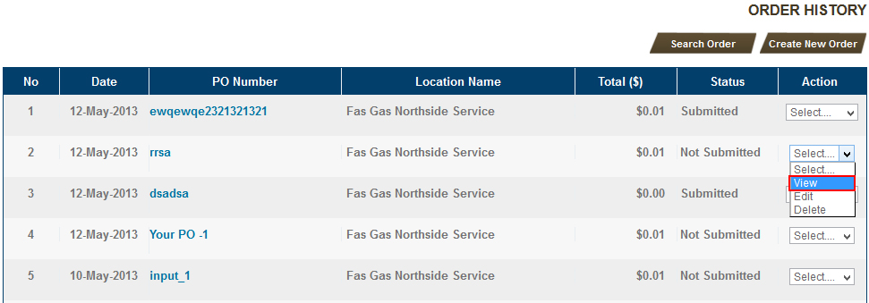

**Step 2:** View all details order

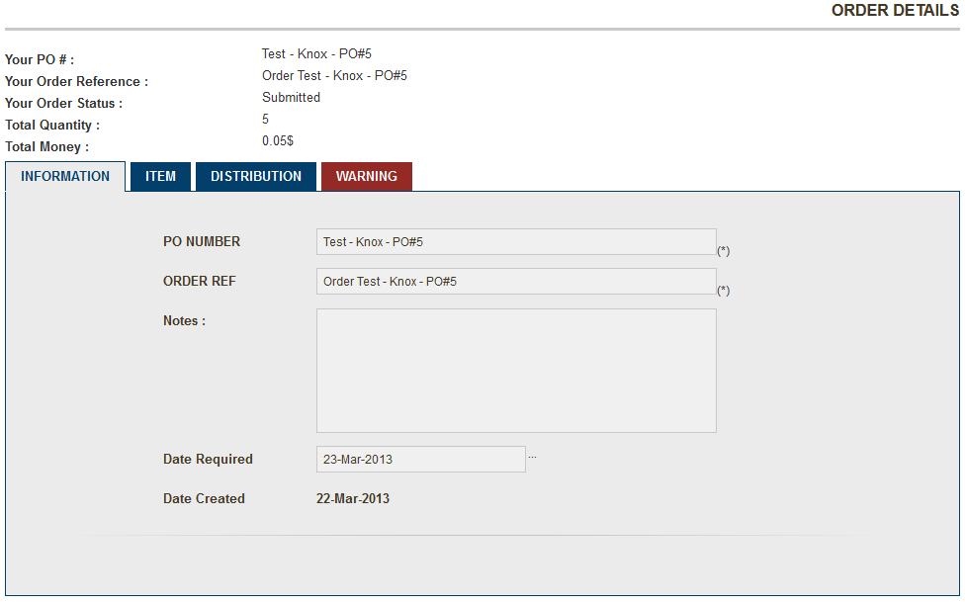

## **Delete Order**

**Step 1:** Click drop-down in Menu Order and select Delete.

* User can delete order what is **not submitted**, **On Session**, **pending**.
* User must roles to delete order another

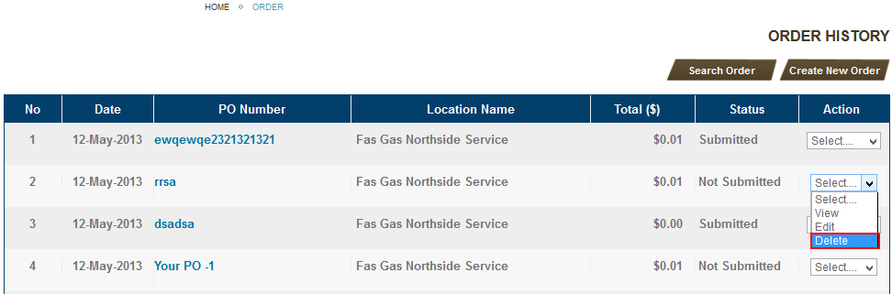

**Step 2:** The Conform form will appear. Click OK if you want to delete this order.

Notes:

* The order is change to deleted status.
* Customer can’t view order what is deleted.



# Shipping

## **View Shipping History**

**Step 1:** Click menu “ Shipping “ on top Website. The Shipping History will appear.

Notes:

* Only Admin can enter the infomaion shipping.
* The order is not can’t delete, edit when in-production, shipped status.
* User can click Tracking Number to view details

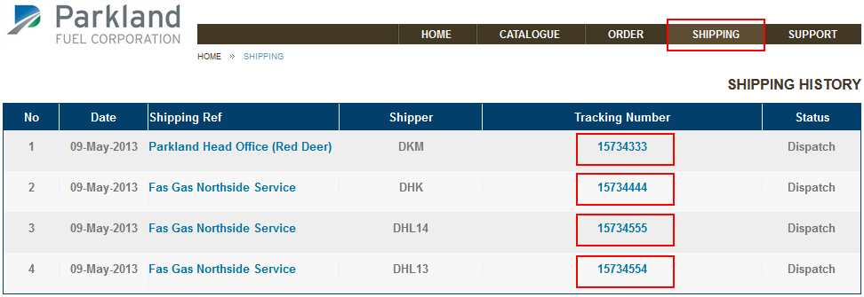

* The information shipping will appear in Tab Distribution at Order.

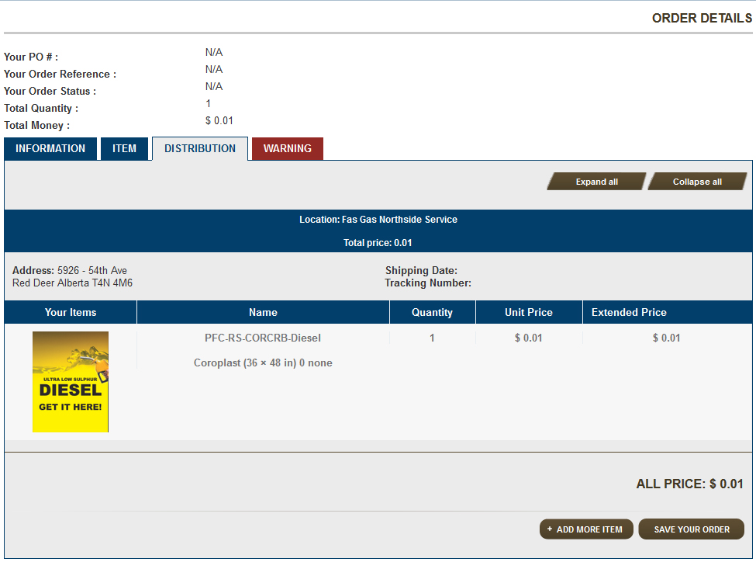

# Support

## **Feedback**

If you have feedback, please enter the feedback form. Then click Send your Feedback button.

